**NAME: JEEVITHA.S-192324020**

**DATA BASE MANAGEMENT SYSTEM FOR WEB APPLICATION(CSA0555)**

**ASSIGNMENT 15: HOSPITAL INFORMATION SYSTEM**

**CREATE A TABLE:**

CREATE TABLE Doctor (

DoctorID NUMBER PRIMARY KEY,

Name VARCHAR2(100),

Specialty VARCHAR2(100)

);

CREATE TABLE Patient (

PatientID NUMBER PRIMARY KEY,

Name VARCHAR2(100),

DoctorID NUMBER,

Status VARCHAR2(50),

FOREIGN KEY (DoctorID) REFERENCES Doctor(DoctorID)

);

**CODE:**

CREATE OR REPLACE PROCEDURE AdmitPatient (

p_PatientID IN NUMBER

) AS

BEGIN

UPDATE Patient

SET Status = 'Admitted'

WHERE PatientID = p_PatientID;

COMMIT;

END;

CREATE OR REPLACE PROCEDURE DischargePatient (

p_PatientID IN NUMBER

) AS

BEGIN

UPDATE Patient

SET Status = 'Discharged'

WHERE PatientID = p_PatientID;

COMMIT;

END;

**INSERT VALUES:**

INSERT INTO Doctor VALUES (100, 'Dr.Jeevitha', 'Cardiology');

INSERT INTO Doctor VALUES (2, 'Dr.Jai', 'Neurology');

INSERT INTO Patient VALUES (1, 'Surya', 1, 'Admitted');

INSERT INTO Patient VALUES (1, 'Anitha', 2, 'Admitted');

**CODE:**

BEGIN

AdmitPatient(2);

END;

BEGIN

DischargePatient(1);

END;

**DISPLAY:**

SELECT * FROM DOCTOR

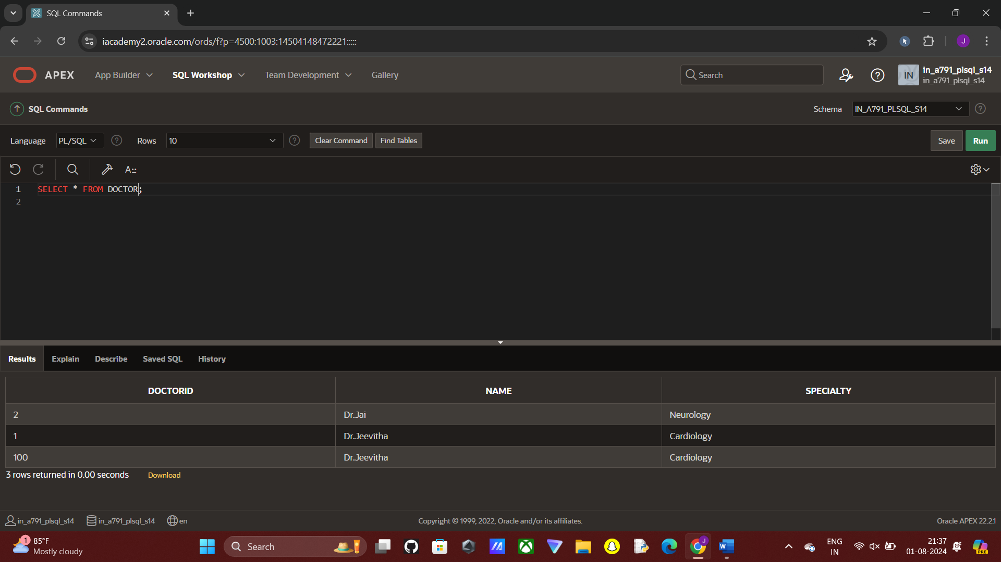

SELECT * FROM PATIENT

